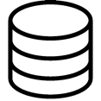

Dataset

$$(X_{t},{\tilde{X}}_{t} , A_{t}, R_{t})$$

$${\tilde{X}}_{t}$$

$$A_{t}$$

$$X_{t}$$

Performance

recodreder

Model

Preprocessing

Monitoring

Interpretor